ESA EPROM ERASER
The Most Elegant & Efficient EPROM Eraser that lets you erase so many devices in a single shot!

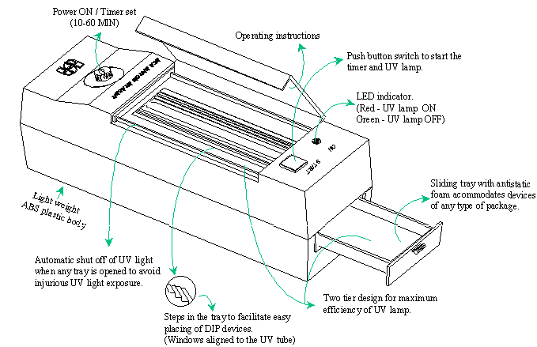

SPECIFICATIONS:
Capacity
Top Tray | : | Upto 8 devices of 24 pin to 40 pin 600 mil devices or
Bottom Tray | : | Upto 16 devices of 20 pin to 40 pin 300 mil devices
UV Light Source | : | 2537 ⁰ A, 6W, 9 inch tube
Input Line Voltage | : | 240V AC
Power consumption | : | 10W(approx)
Dimension | : | 85mm (W) X 95mm (H) X 295mm (L)
Weight | : | 1220g (approx.)

